Course: Programming Fundamental – ENSF 337

Lab #: Lab 4  
Instructor: Mansouri Habibabadi  
Student Name: Drew Hengehold

Lab Section: B01

Date submitted: October 12, 2022

UCID: 30151823

**Exercise A**

**Exercise B**

**Exercise C**

**Source Code**

// lab2exC.c

// ENSF 337 Lab 4 Exercise C

//Author of Elements Drew Hengehold

#include <stdio.h>

#define ELEMENTS(x) (sizeof(x)/sizeof(x[0]))

int main()

{

int size;

int a[] = {45, 67, 89, 24, 54};

double b[20] = {14.5, 61.7, 18.9, 2.4, 0.54};

size = ELEMENTS(a);

printf("Array a has 5 elements and macro ELEMENTS returns %d\n", size);

size = ELEMENTS(b);

printf("Array b has 20 elements and macro ELEMENTS returns %d\n", size);

return 0;

}

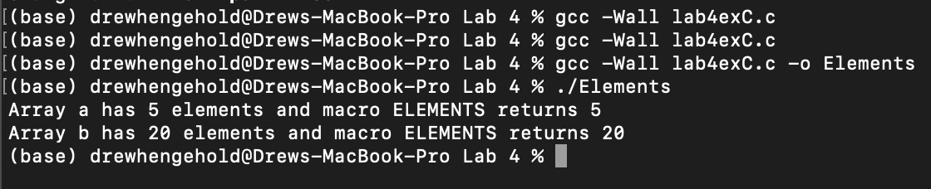

**Screenshot of Output**

**Exercise D**

**Source Code**

/*

* lab4exD.c

*

* ENSF 337 Lab 4 Exercise D

* AUTHOR OF FUCNTIONS Drew Hengehold

*/

#include <stdio.h>

#include <string.h>

int my_strlen(const char *s);

/* Duplicatesmy_strlen from <string.h>, except return type is int.

* REQUIRES

* s points to the beginning of a string.

* PROMISES

* Returns the number of chars in the string, not including the

* terminating null.

*/

void my_strncat(char *dest, const char *source, int);

/* Duplicatesmy_strncat from <string.h>, except return type is void.

* dest and source point to the beginning of two strings.

* PROMISES

* appends source to the end of dest. If length of source is more than n.

* Only copies the first n elements of source.

*/

int my_strncmp(const char* str1, const char* str2);

/* Duplicatesmy_strncmp from <string.h>, except return type is int.

* REQUIRES

* str1 points to the beginning of a string, and str2 to the beginning of

* another string.

* PROMISES

* Returns 0 if str1 and str2 are idntical.

* Returns a negative number of str1 is less that str2.

* Return a psitive nubmer of str2 is less than str1.

*/

int main(void)

{

char str1[7] = "banana";

const char str2[] = "-tacit";

const char* str3 = "-toe";

char str5[] = "ticket";

char my_string[100]="";

int bytes;

int length;

int y;

printf("\nTESTING strlen FUNCTION ... \n");

/* using strlen function */

length = (int) strlen(my_string);

printf("\nExpected to display: my_string length is 0.");

printf("\nmy_string length is %d.", length);

/* using sizeof operator */

bytes = sizeof (my_string);

printf("\nExpected to display: my_string size is 100 bytes.");

printf("\nmy_string size is %d bytes.", bytes);

/* using strcpy C libarary function */

strcpy(my_string, str1);

printf("\nExpected to display: my_string contains banana.");

printf("\nmy_string contains %s", my_string);

length = (int) strlen(my_string);

printf("\nExpected to display: my_string length is 6.");

printf("\nmy_string length is %d.", length);

my_string[0] = '\0';

printf("\nExpected to display: my_string contains \"\".");

printf("\nmy_string contains:\"%s\"", my_string);

length = (int) strlen(my_string);

printf("\nExpected to display: my_string length is 0.");

printf("\nmy_string length is %d.", length);

bytes = sizeof (my_string);

printf("\nExpected to display: my_string size is still 100 bytes.");

printf("\nmy_string size is still %d bytes.", bytes);

printf("\n\nTESTING strncat FUNCTION ... \n");

/* strncat append the first 3 characters of str5 to the end of my_string */

strncat(my_string, str5, 3);

printf("\nExpected to display: my_string contains \"tic\"");

printf("\nmy_string contains \"%s\"", my_string);

length = (int) strlen(my_string);

printf("\nExpected to display: my_string length is 3.");

printf("\nmy_string length is %d.", length);

strncat(my_string, str2, 4);

printf("\nExpected to display: my_string contains \"tic-tac\"");

printf("\nmy_string contains:\"%s\"", my_string);

/* strncat append ONLY up ot '\0' character from str3 -- not 6 characters */

strncat(my_string, str3, 6);

printf("\nExpected to display: my_string contains \"tic-tac-toe\"");

printf("\nmy_string contains:\"%s\"", my_string);

length = (int) strlen(my_string);

printf("\nExpected to display: my_string has 11 characters.");

printf("\nmy_string has %d characters.", length);

printf("\n\nUsing strcmp - C library function: ");

printf("\nExpected to display: \"ABCD\" is less than \"ABCDE\"");

printf("\n\"ABCD\" is less than \"ABCDE\"... strcmp returns %d", strcmp("ABCD", "ABCDE"));

printf("\n\nTESTING strcmp FUNCTION ... \n");

if((y = strcmp("ABCD", "ABND")) < 0)

printf("\n\"ABCD\" is less than \"ABND\" ... strcmp returns %d", y);

if((y = strcmp("ABCD", "ABCD")) == 0)

printf("\n\"ABCD\" is equal \"ABCD\" ... strcmp returns %d", y);

if((y = strcmp("ABCD", "ABCd")) < 0)

printf("\n\"ABCD\" is less than \"ABCd\" ... strcmp returns %d", y);

if((y = strcmp("Orange", "Apple")) > 0)

printf("\n\"Orange\" is greater than \"Apple\" ... strcmp returns %d\n", y);

return 0;

}

int my_strlen(const char *s){

int counter = sizeof(s)/ *s;

return counter;

}

void my_strncat(char *dest, const char *source, int e){

while(*dest!= '\0'){

dest++;

}

for(int i = 0; *source != '\0' && i < e; i++){

*dest = *source;

source++;

dest++;

}

*dest = 0;

}

int my_strncmp(const char *str1, const char *str2){

while(*str1 == '\0' && *str2 == '\0'){

return (-1);

}

while(*str1 == '\0' && *str2 == '\0'){

return 1;

}

while(*str1 == '\0' && *str2 == '\0'){

if(*str1 == *str2)

return 0;

if(*str1 < *str2)

return (-1);

else

return 1;

}

return 0;

}

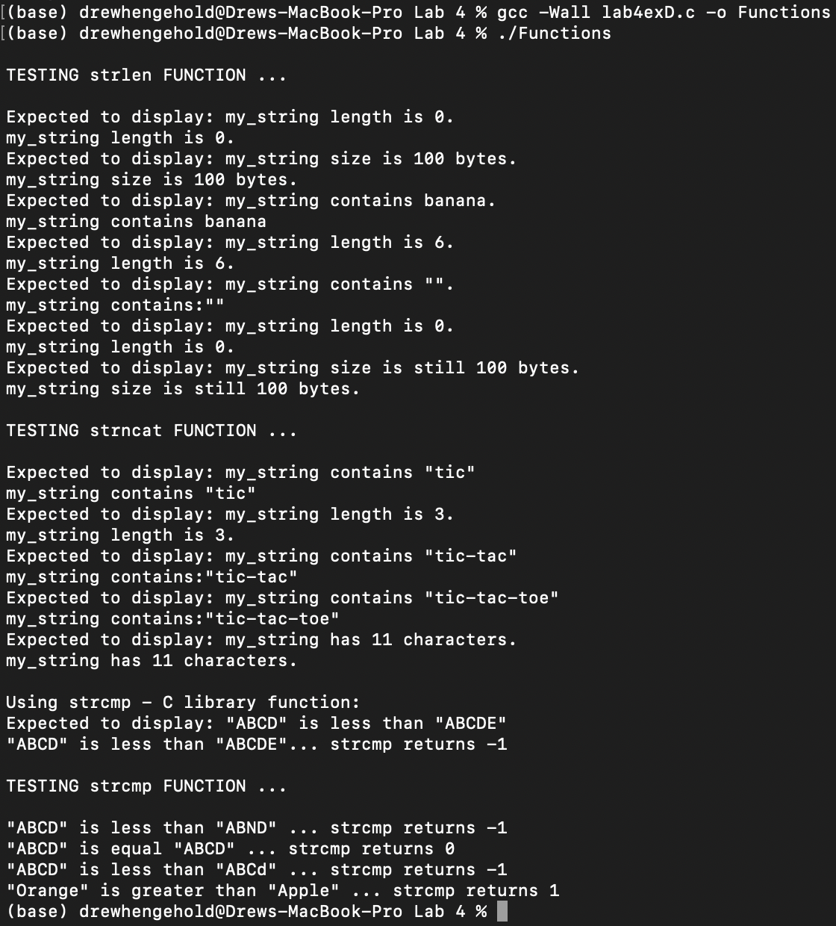

**Output Example**

**Exercise E**

**Source Code prog_two.c:**

/* prog_two.c

* ENSF 337 Lab 4 Exercise E

*

*/

#include <stdio.h>

#include <limits.h>

#include <math.h>

#include "read_input.h"

#define SIZE 50

int main(void)

{

double n = 0;

char digits[SIZE];

int y = EOF;

while (1)

{

printf("\n\nEnter an integer or press Ctrl-D to quit: ");

y = read_real(digits, SIZE, &n);

if(y == 1)

if(fmod(n,1) == 0){printf("\nYour integer value is: %d", (int)n);}

else{printf("\nYour double value is: %lf", n);}

else if(y == EOF){

printf("\nGood Bye.\n");

break;

}

else

printf("\n%s is an invalid integer.", digits);

}

return 0;

}

**Source Code read_double.c:**

//

// read_double.c

// Lab4 Playground

//

// Created by Drew Hengehold on 10/11/22.

//

#include "read_input.h"

#include <stdio.h>

int read_real(char* digits, int n, double * num){

if(get_string(digits, n)== EOF)

return EOF;

if(is_valid_double(digits)){

if(digits[0] == '-')

*num = -convert_to_double(digits + 1);

else if(digits[0] == '+')

*num = convert_to_double(digits + 1);

else

*num = convert_to_double(digits);

return 1;

}

return 0;

}

/* REQUIRES

* n > 0, n is large enough to handle longest expected line of input.

* Array elements digits[0], ..., digits[n-1] exist.

* num points to a variable.

*

* PROMISES:

* A line of user input is copied into the array, possibly after some

* editing.

* If a double is successfully read from the input, that double is copied

* into *num and 1 is returned.

* EOF is returned if user enters end-of-file (Ctrl-D on a Unix-like

* system, and Ctrl-Z on Windows).

* 0 is returned if the user's input can't be read as a double.

*/

int is_valid_double(const char* digits){

int valid = 1;

int i;

/* i = index where first digit should be */

if(digits[0] == '+' || digits[0] == '-')

i = 1;

else

i = 0;

// printf("\n Valid1: %d\n", valid);

/* Must have at least one digit, and no non-digits. */

if (digits[i] == '\0')

valid = 0;

else

// printf("\n Valid2: %d\n", valid);

// printf("\n%s\n", digits);

while (valid && (digits[i] != '\0')) {

if((digits[i] < '0' || digits[i] > '9') && digits[i] != '.')

valid = 0;

// printf("\n Valid3: %d\n", valid);

i++;

}

return valid;

}

/* REQUIRES: digits points to the beginning of a valid C string.

*

* PROMISES: Returns 1 if all characters in digits are

* acceptable as characters in a real number.

* Otherwise returns zero.

*/

double convert_to_double(const char *digits){

double sum = 0.0;

double sum2 = 0.0;

int i = 0;

int checker =0;

while(digits[i] != '\0') {

if(digits[i] != '.'){

if(checker == 1)

{

sum2 = sum2/10 + (((double)(digits[i] - '0'))/10);

i++;

}

else

{

sum = 10 * sum + (digits[i] - '0');

i++;

}

}

else

{

checker = 1;

i++;

}

}

sum += sum2;

return sum;

}

/* REQUIRES: digits points to a valid C string

* and is_valid_double(digits) is true.

* PROMISES: computes and returns the equivalent double value of the string

* characters.

*/

**Output screenshot**